Software Requirements Specification

Version 1.0

May 6, 2024

Fleet Management System

Yashwanth Karuparthi

M Muhammed Aqeel

Submitted in partial fulfillment of requirements of IS F341

**Table of Contents**

Table of Contents……………….……………….……………….……………….……………….……2

List of Figures……………….……………….……………….……………….……………….………..3

1 Introduction……………….……………….……………….……………….……………….………...4

1.1 Purpose……………….……………….……………….……………….……………….….4

1.2 Scope of the Project……………….……………….……………….……………….…….4

1.3 Glossary……………….……………….……………….……………….……………….…4

1.4 References……………….……………….……………….……………….……………….5

1.5 Overview ……………….……………….……………….……………….…………………5

2 System Environment……………….……………….……………….……………….……………….6

3 User Characteristics……………….……………….……………….……………….………………..7

4 External Interface Requirements……………….……………….……………….……………….….8

5 Functional Requirements Specification……………….……………….……………….………...…9

5.1 Logistic Manager Use Cases……………….……………….……………….…………...9

5.2 Driver Use Cases……………….……………….……………….……………….………..10

5.3 Retailer Use Cases……………….……………….……………….……………….……...11

5.4 Company Staff Use Cases……………….……………….……………….……………...12

5.5 Functional Requirements……………….……………….……………….………………..13

5.5.1 Add driver & truck info……………….……………….……………….………..13

5.5.2 Update driver & truck info……………….……………….…………………….14

5.5.3 Update deliver info……………….……………….……………….……………14

5.5.4 Update time of visit at each delivery point……………….……………….…..15

5.5.5 Update delivery status……………….……………….……………….………..16

5.5.6 Update payment status……………….……………….………………..….…..16

5.5.7 Check delivery info……………….……………….……………….……….…...17

5.5.8 Check truck & driver info……………….……………….………..…………….17

5.5.9 Check real time info……………….……………….……………….……….….18

6 Non-Functional Requirements……………….……………….……………….…………………….19

6.1 Quality Attributes……………….……………….……………….……………….………..19

6.2 Logical Structure of Data……………….……………….……………….………………..20

7 Component Diagram……………….……………….……………….……………….……………….24

Index……………….……………….……………….……………….……………….………………….26

**List of Figures**

Figure 1 - System Environment Diagram………………………………………………………………6

Figure 2 - Logistic Manager Use Case Diagram………………………………………………………9

Figure 3 - Driver Use Case Diagram………………………………………………………………….10

Figure 4 - Retailer Use Case Diagram………………………………………………………………..11

Figure 5 - Company Staff Use Case Diagram……………………………………………………….12

Figure 6 - Logistic Structure of Data Diagram………………………………………………………..20

Figure 7 - Component Diagram………………………………………………………………………..24

**1 Introduction**

**1.1 Purpose**

The purpose of the document for the Fleet Management System is to outline the functional and non-functional requirements necessary to develop a comprehensive platform that facilitates efficient management of fleet operations. By defining the specific interactions between various actors and the system, this document aims to ensure clear understanding and alignment among stakeholders regarding the system's capabilities and functionalities.

**1.2 Scope of the Project**

The scope of this project encompasses the entire lifecycle of a fleet management system, from gathering requirements to deployment and maintenance. The system will include features such as vehicle registration, real-time tracking, maintenance scheduling, and reporting. It will target both administrators responsible for managing the fleet and end-users who need access to specific functionalities such as tracking vehicles or reporting issues. The software will be designed to handle a range of fleet sizes, from small-scale operations to large enterprises managing thousands of vehicles.

**1.3 Glossary**

To ensure clarity throughout this document, a glossary of key terms is provided below:

| **Term** | **Definition** |
| --- | --- |
| **Fleet** | A group of vehicles managed by an organization. |
| **GPS** | Global Positioning System. A satellite-based navigation system. |
| **API** | Application Programming Interface. A set of rules and tools for building software applications. |
| **CRUD** | Create, Read, Update, Delete. Basic functions of persistent storage. |
| **UI** | User Interface. The means by which users interact with a computer system. |
| **Administrator** | A user with elevated privileges managing the fleet management system. |
| **End-user** | A person interacting with the fleet management system for specific tasks. |
| **Real-time** | Immediate feedback or updates with minimal delay. |
| **Maintenance** | The process of preserving and maintaining the operational status of vehicles. |
| **Reporting** | Generating and analyzing data for insights into fleet management. |
| **Authentication** | The process of verifying user identity to grant access to the system. |
| **Encryption** | Converting data into a coded form to prevent unauthorized access. |
| **Log. Mgr** | Abbreviation for Logistic Manager |

**1.4 References**

IEEE. IEEE Std 830-1998 IEEE Recommended Practice for Software Requirements Specifications. IEEE Computer Society, 1998

***1.5 Overview of Document***

This document will provide a structured guide to the fleet management software project. It will begin with the requirements analysis, detailing the functional and non-functional requirements of the system. Following this, the design phase will outline the system architecture, database design, and user interface design. The subsequent sections will cover implementation, deployment, and maintenance aspects. Each section will delve into specific details, providing a comprehensive understanding of the project and its various stages.

**2 System Environment Diagram**

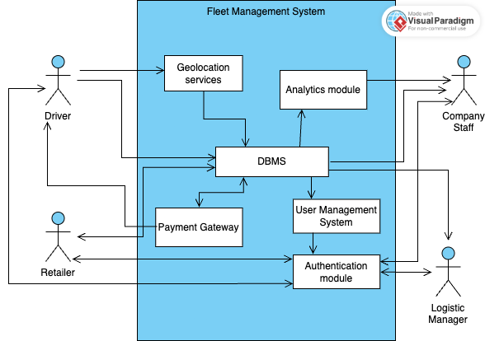

**Figure 1 - System Environment Diagram**

The Fleet management system has four active actors. The Logistic Manager, Driver, Company staff and Retailer have access to the delivery information which is updated by the Logistic manager at the beginning of the delivery journey. All the actors have direct access to the information from Database. Logistic Manager and Driver are the only actors who can edit or update relevant information.

**3 User Characteristics**

1. Driver:
   * Technically proficient in using digital tools and mobile devices.
   * Requires a user-friendly interface with intuitive controls for data input.
   * Needs real-time updates and notifications to efficiently carry out delivery tasks.
   * May work in varying environmental conditions, so the interface should be accessible and usable under different circumstances (e.g., while driving or in adverse weather).
   * May have limited time for data entry tasks, so the interface should prioritize efficiency and minimize manual input.
2. Logistic Manager:
   * Technical proficiency for using mobile devices and digital tools is required
   * May require reporting features to track performance metrics and optimize operations
   * Prefers a centralized platform for managing truck inventory, routes and schedules
   * May need administrative controls to manage user accounts and permissions within the system
3. Company staff:
   * Needs access to real-time updates on truck locations, delivery status
   * requires user-friendly interface for retrieving information about trucks, delivered order and payment status
   * Values data accuracy and reliability for decision-making purposes
   * May need administrative controls to manage user accounts and permissions within the system
   * Prefers customizable dashboards and reports to monitor key performance indicators (KPIs) of deliveries
4. Retailer:
   * Technically proficient in using digital tools and mobile devices.
   * Requires access to timely information about delivery schedules and expected arrival times.
   * Prefers a simplified interface for tracking order.
   * Values transparency and reliability in communication regarding delivery status and payment updates.

**4. External Interface Requirements**

Each part of the user interface intends to be as user friendly as possible. The fonts and buttons used will be intended to be very fast and easy to load. the pages will be kept light in space so that it won’t take a long time for the page to load.

The starting page is the login page. Each user is given input fields to enter credentials to login. Once the user is logged in, the user gets auto-logged out after 30 mins of inactivity.

### **Driver Interface**

* input
  + refueling station information (after loading stock)
  + Current city (real-time)
  + Retailer delivery completion (real-time)
  + Payment status received from retailer (real-time)
* Output
  + Confirmation message for data updates
  + Payment receipt to print

### **Logistic Manager Interface**

* Input
  + Truck registration number
  + Order of retailer locations (including city information)
  + Stock information for each retailer
* Output
  + Confirmation message for route creation

### **Company Staff Interface**

* Output
  + Driver and Truck details
  + Current city of each truck
  + List of retailers delivered to by each truck
  + Payment status for each driver

### **Retailer Interface**

* Output
  + Estimated arrival time of the truck
  + Date and time of last delivery
  + Stock information received

### **Geolocation Service**

* The system shall utilize GPS (Global Positioning System) or similar technology to track the real-time location of each vehicle in the fleet.
* The system shall update vehicle locations at regular intervals, with a frequency of [specify frequency, e.g., every 30 seconds].
* The accuracy of vehicle location tracking shall be within [specify accuracy, e.g., within 10 meters].
* The system shall provide APIs or interfaces for accessing vehicle location data.
* Geolocation data shall be securely transmitted and stored to protect sensitive information and ensure data integrity.

**5 Functional Requirements Specification**

**5.1 Logistic Manager Use Cases**

The Logistic Manager has following use cases:

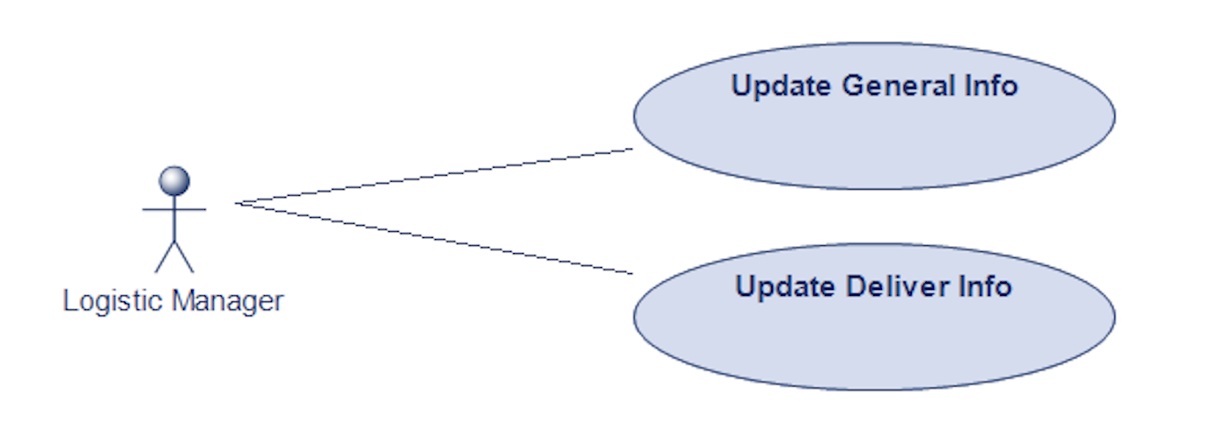

**Figure 2 - Logistic Manager Use Case Diagram**

**Update general info use case**

1. Use Case: Add driver & truck information
2. XRef: 2.3.1

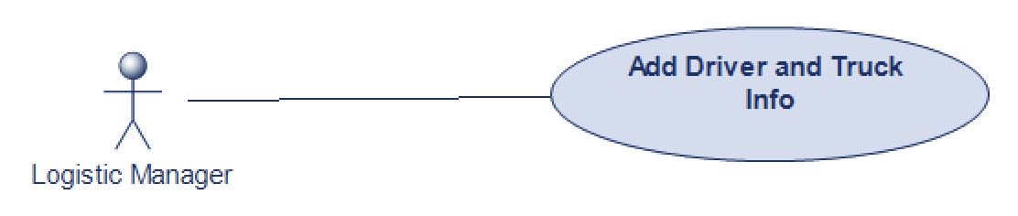

1. Use Case: Update driver & truck information
2. XRef: 2.3.2

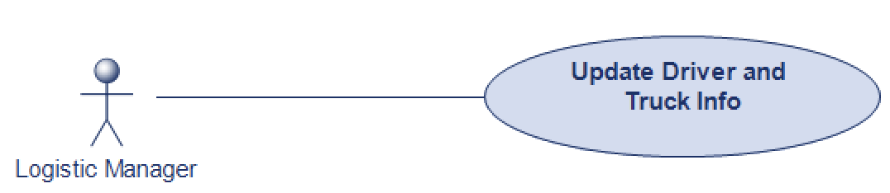

**Update deliver info use case**

1. Use Case: Update delivery info
2. XRef: 2.3.3

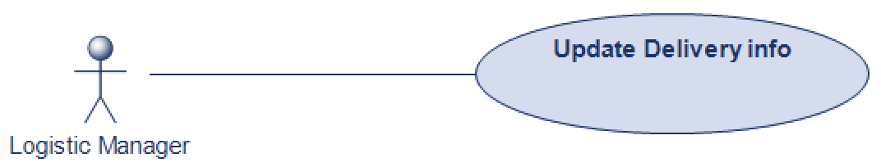

**5.2 Driver Use Cases**

The Driver has following use cases:

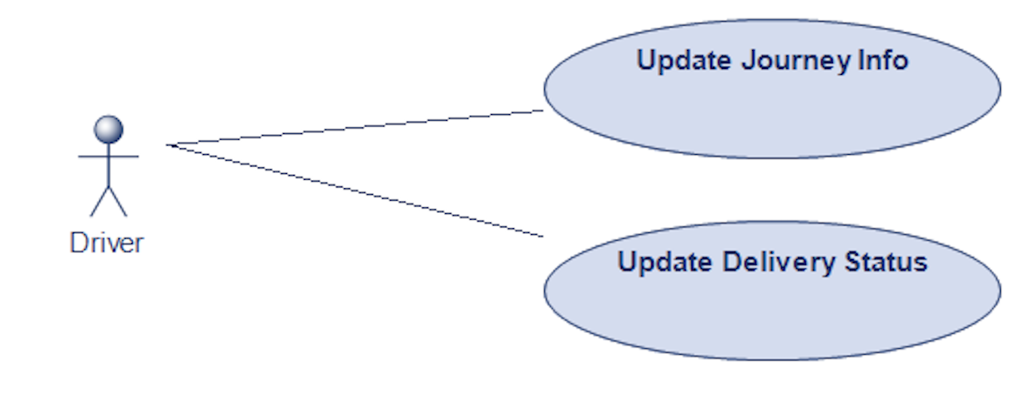

**Figure 3 - Driver Use Case Diagram**

**Update journey info use cases**

1. Use Case: update delivery point visit time
2. Xref: 2.3.4

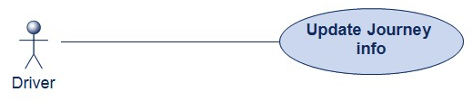

**Update delivery status**

1. Use case: update delivery status
2. XRef: 2.3.5

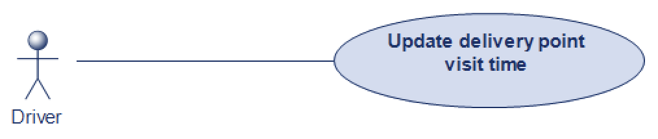

1. Use case: update payment status
2. XRef: 2.3.6

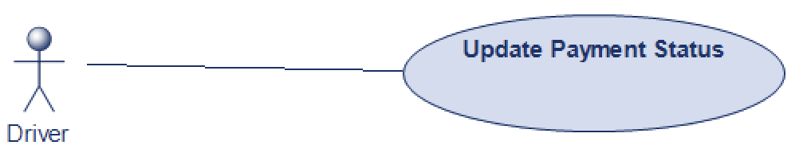

**5.3 Retailer Use Cases**

The retailer has following use cases:

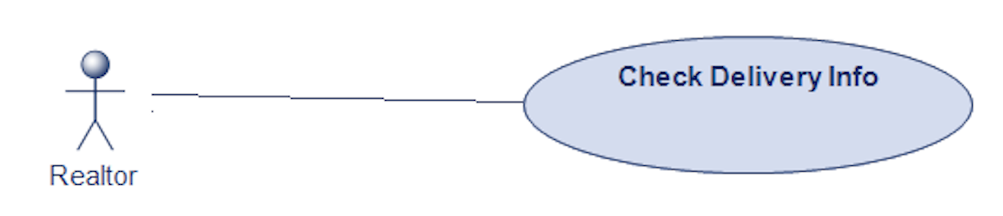

**Figure 4 - Retailer Use Case Diagram**

**Check delivery info use case**

1. XRef: 2.3.7



**5.4 Company Staff use cases**

The company staff has following use cases:

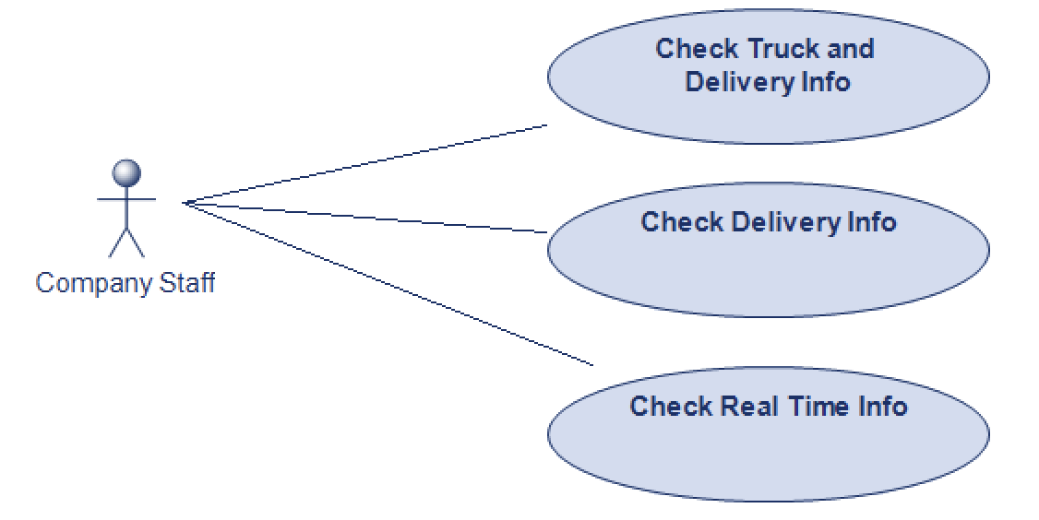

**Figure 5 - Company Staff Use Case Diagram**

**Check truck & driver info use case**

1. XRef: 2.3.8

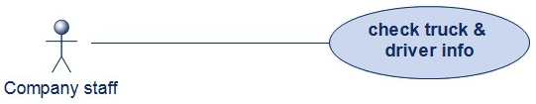

**Check delivery info use case**

1. XRef: 2.3.7

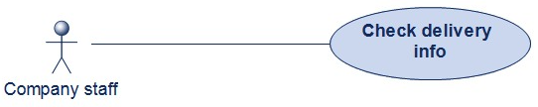

**Check real time info use case**

1. XRef: 2.3.9



**5.5 Functional Requirements**

**5.5.1 Add driver & truck info**

| **Use case name** | Add driver & truck info |
| --- | --- |
| **XRef** | 2.2.1 |
| **Trigger** | Logistic Manager selects to add a new driver or truck to the database |
| **Precondition** | The logistic manager has logged in to his account and accessed Log. mgr main screen |
| **Basic Path** | 1. The system accesses the user management system and the database and presents an alphabetical list of all the drivers and the trucks in separate tables 2. Log. mgr selects to add a driver or a truck 3. If driver is chosen, the driver name is entered the and system check the user management system if the driver exists 4. If truck is chosen, the truck registration number is entered and the system checks the database if the truck’s registration number already exists 5. If the info does not pre-exist, the Log. mgr enters and submits the info into the database. |
| **Alternative paths** | In step 2 and 3, if the info pre-exists, the user is prompted to verify the info entered.  In step 5, if any input field is empty, the user is prompted for an entry. No validation for correctness is made. |
| **Postcondition** | The driver/ truck has been added to the database and the driver info is updated into user management system |
| **Exception path** | The user may abandon the operation at any time. |
| **Other** | The driver info includes: name, email id, employee number, mobile number, driver’s license.  The truck info includes: truck company, truck model number, truck registration number, truck chassis number. |

**5.5.2 Update driver & truck info**

| **Use case name** | Update driver & truck info |
| --- | --- |
| **XRef** | 2.2.1 |
| **Trigger** | Logistic Manager selects to update driver or truck in the database |
| **Precondition** | The logistic manager has logged in to his account and accessed Log. mgr main screen |
| **Basic Path** | 1. The system accesses the user management system and the database and presents an alphabetical list of all the drivers and the trucks in separate tables 2. Log. mgr selects a driver or a truck 3. If a driver is chosen, the system presents the driver info in grid form for changes. 4. If a truck is chosen, the system presents the truck info in grid form for changes. 5. The user updates info and submits 6. The system checks required fields are not blank. |
| **Alternative paths** | In step 6, if any required field is blank, the Editor is instructed to add an entry. No validation for correctness is made. |
| **Postcondition** | The database and the user management system has been updated |
| **Exception path** | If the driver or truck is not already in the database, the use case is abandoned. The user may abandon the operation at any time. |
| **Other** | This use case is not used when an add use case is more appropriate. |

**5.5.3 Update deliver info**

| **Use case name** | Update deliver info use case |
| --- | --- |
| **XRef** | 2.2.2 |
| **Trigger** | Logistic Manager selects to update the delivery info |
| **Precondition** | The logistic manager has logged in to his account and accessed Log. mgr main screen |
| **Basic Path** | 1. The system presents field to update the deliver information 2. The fields are of dropdown type, pre-existing information is displayed for selection of drivers, trucks 3. One table field is used to add stock information 4. Another table field is used where the user is prompted to select options from dropdown on retailers location. |
| **Alternative paths** | In step 3 and 4, if any required field is blank, the Editor is instructed to add an entry. No validation for correctness is made. |
| **Postcondition** | The database has been updated |
| **Exception path** | If the driver or truck info is not already in the database, the use case is abandoned. The user may abandon the operation at any time. |
| **Other** | The fields include: driver name, truck number, retailer name, retailer location, order of location visits.  For retailers location, the user can change the order of visit by changing the order in the table. |

**5.5.4 Update time of visit at each delivery point**

| **Use case name** | update time of visit at each delivery point |
| --- | --- |
| **XRef** | 2.2.2 |
| **Trigger** | Driver selects to update the estimated time of visit at each delivery point |
| **Precondition** | The driver has logged in to his account and accessed delivery checklist displayed in main screen |
| **Basic Path** | 1. The system presents the delivery info updated by Log. mgr in a tabular format 2. The driver chooses the estimated time of arrival field for each retailer in the table 3. The date time field displays the calendar for selecting the date and also a scroller to update the time of arrival. 4. After updating the time of arrival for all retailers, the driver submits and the result gets updated in the database. |
| **Alternative paths** | In step 4, if any time field is blank, the Driver is instructed to add an entry. No validation for correctness is made. |
| **Postcondition** | The database has been updated |
| **Exception path** | The driver may abandon the operation at any time |
| **Other** | None |

**5.5.5 Update delivery status**

| **Use case name** | update delivery status |
| --- | --- |
| **XRef** | 2.2.2 |
| **Trigger** | Driver selects to update the delivery status for each retailer |
| **Precondition** | The driver has logged in to his account and accessed delivery checklist displayed in main screen |
| **Basic Path** | 1. The system presents the delivery info updated by Log. mgr in a tabular format 2. The driver chooses to update the delivery status for selected retailer 3. Using the radio button tool, the driver touches on the button which indicates that the delivery has been done |
| **Alternative paths** | None |
| **Postcondition** | The database has been updated and payment status button is now available to edit |
| **Exception path** | The driver may abandon the operation at any time |
| **Other** | None |

**5.5.6 Update payment status**

| **Use case name** | update payment status |
| --- | --- |
| **XRef** | 2.2.2 |
| **Trigger** | Driver selects to update the delivery status for each retailer after stock have been delivered |
| **Precondition** | The driver has updated the delivery status to ‘delivered’ and is in the same page when updating delivery status |
| **Basic Path** | 1. The system presents the delivery info updated by Log. mgr in a tabular format 2. The driver chooses to update the payment status for the delivery made for selected retailer 3. Using the radio button tool, the driver touches on the button which indicates that the payment has been done |
| **Alternative paths** | None |
| **Postcondition** | The database has been updated |
| **Exception path** | The driver may abandon the operation at any time |
| **Other** | None |

**5.5.7 Check delivery info**

| **Use case name** | Check delivery info |
| --- | --- |
| **XRef** | 2.2.3, 2.2.4 |
| **Trigger** | Retailer selects to check delivery info |
| **Precondition** | The retailer has logged in to his account and accessed retailer main screen |
| **Basic Path** | 1. The system presents the deliver info in a tabular format |
| **Alternative paths** | None |
| **Postcondition** | None |
| **Exception path** | The retailer may abandon the operation at any time |
| **Other** | The info displayed include: driver’s name, date & time of arrival, location of truck, ordered stock info |

**5.5.8 Check truck & driver info**

| **Use case name** | Check truck & driver info |
| --- | --- |
| **XRef** | 2.2.4 |
| **Trigger** | Company staff selects to check truck & driver info |
| **Precondition** | The Company staff has logged in to their account and accessed staff main screen |
| **Basic Path** | 1. The system presents the truck and driver info available in database in a tabular format |
| **Alternative paths** | None |
| **Postcondition** | None |
| **Exception path** | The company staff may abandon the operation at any time |
| **Other** | The driver info includes: name, email id, employee number, mobile number, driver’s license.  The truck info includes: truck company, truck model number, truck registration number, truck chassis number. |

**5.5.9 Check real time info**

| **Use case name** | Check real time info |
| --- | --- |
| **XRef** | 2.2.4 |
| **Trigger** | Company staff selects to check real time info regarding the truck |
| **Precondition** | The Company staff has logged in to their account and accessed the delivery info of chosen truck |
| **Basic Path** | 1. The system presents the truck and driver info available in database in a tabular format along with real time info button 2. The user presses the button to navigate to real time info dashboard page 3. The dashboard presents info about city the truck is in and which retailer the truck has delivered and stopped for delivering |
| **Alternative paths** | In step 1, if the truck is inactive, the real time info button is turned off. |
| **Postcondition** | None |
| **Exception path** | The company staff may abandon the operation at any time |
| **Other** | None |

**6 Non-Functional Requirements**

**6.1 Quality Attributes**

1. Performance

* The system shall provide a responsive time of less than 2 seconds for all user interactions, including login data updates and data writes.

1. Reliability

* The system shall maintain an uptime of at least 90%, excluding scheduled maintenance windows.
* In the event of server failure, the system shall automatically failover to a backup server within 10 seconds without data loss.

1. Security

* User authentication shall be performed using strong encryption methods, including password hashing and salting.
* The system shall enforce role-based access control (RBAC) to ensure that only authorized users can perform sensitive operations such as data writes or updates.

1. Portability

* The system shall be compatible with modern web browsers and mobile softwares.
* The system shall be deployable on Google Cloud Platform.

**6.2 Logical Structure of Data**

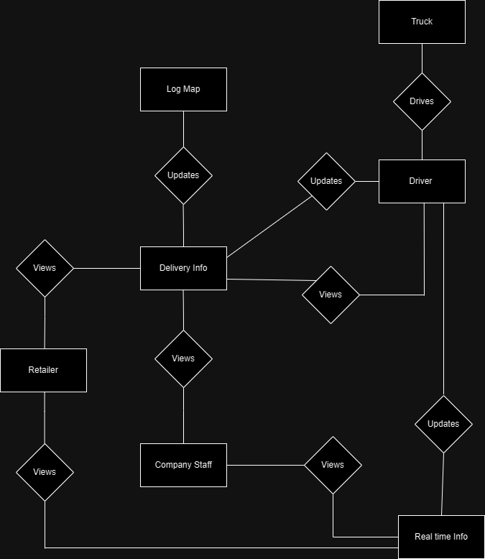

**Figure 6 - Logistic Structure of Data Diagram**

The data description of each of the entities is as follows:

**Logistic Manager Data Entity**

| **Data Item** | **Type** | **Description** | **Comment** |
| --- | --- | --- | --- |
| **Name** | Text | Name of Logistic Manager |  |
| **Email Address** | Text | Internet address |  |
| **Employee ID** | Text | Employee serial number |  |

**Driver Data Entity**

| **Data Item** | **Type** | **Description** | **Comment** |
| --- | --- | --- | --- |
| **Name** | Text | Name of Driver |  |
| **Email Address** | Text | Internet address |  |
| **Employee ID** | Text | Employee serial number |  |
| **Mobile number** | Integer | Mobile number | May be more than one |
| **Driver’s License** | Integer | Driver’s license |  |

**Truck Data Entity**

| **Data Item** | **Type** | **Description** | **Comment** |
| --- | --- | --- | --- |
| **Company Name** | Text | Name of Truck company |  |
| **Model Number** | Integer | Truck model number |  |
| **Registration number** | Text | Truck registration number |  |
| **Chassis number** | Integer | Truck Chassis number |  |

**Company Staff Data Entity**

| **Data Item** | **Type** | **Description** | **Comment** |
| --- | --- | --- | --- |
| **Name** | Text | Name of Company staff |  |
| **Email Address** | Text | Internet address |  |
| **Mobile Number** | Integer |  | May be more than one |
| **Employee ID** | Text | Employee serial number |  |

**Retailer Data Entity**

| **Data Item** | **Type** | **Description** | **Comment** |
| --- | --- | --- | --- |
| **Name** | Text | Name of Retailer |  |
| **Shop Name** | Text | Name of shop to be delivered |  |
| **Email Address** | Text | Internet address | Optional |
| **Mobile Number** | Text | Retailer contact number | May be more than one |
| **Location** | Integer | Retailer location |  |
| **Opening hours** | Date and Time | Shop opening hours |  |

**Delivery Data Entity**

| **Data Item** | **Type** | **Description** | **Comment** |
| --- | --- | --- | --- |
| **Driver name** | Text | Name of Driver |  |
| **Retailer Name** | Text | Name of Retailer |  |
| **Shop Name** | Text | Name of shop to be delivered |  |
| **Stock** | Text | Delivery stock | May be more than one |
| **Mobile Number** | Text | Retailer contact number | May be more than one |
| **Delivery date & time** | Date and Time | Delivery Date & Time |  |
| **Registration number** | Text | Truck registration number |  |
| **Location** | Integer | Retailer location |  |
| **Order of delivery** | Text | Order of location visit | May be several |

**Real Time Data Entity**

| **Data Item** | **Type** | **Description** | **Comment** |
| --- | --- | --- | --- |
| **Name** | Text | Name of Driver |  |
| **Registration number** | Text | Truck registration number |  |
| **Current City** | Text | City the truck has reached |  |
| **Delivery status** | Boolean | Stock has been delivered | False until updated by driver after delivery |
| **Payment status** | Boolean | Retailer location | False until updated by driver after payment |
| **Opening hours** | Date and Time | Shop opening hours |  |

**7 Component Diagram**

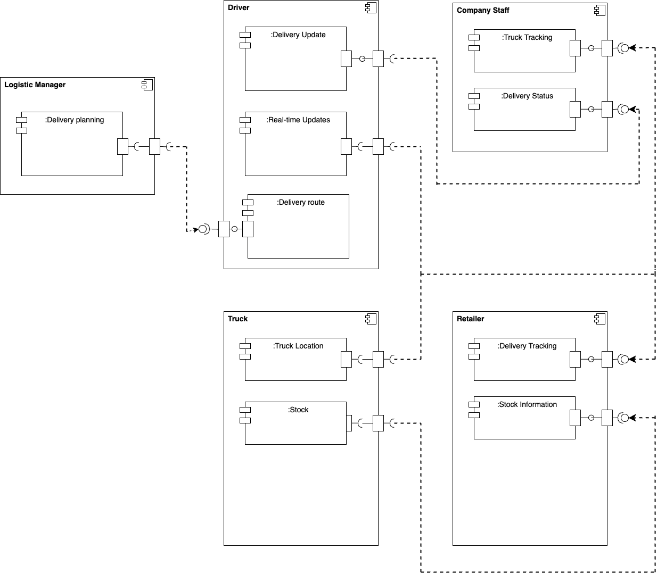

**Figure 7 - Component Diagram**

The Logistic Manager component is geared for delivery planning which comprises modules for updating truck-related, driver-related and delivery-related information. The Delivery planning module allows the actor to update the points of delivery in a city.

The Driver component has modules for inputting and updating delivery information, updated routes and real-time updates during the delivery. The Delivery update allows the driver to update about delivery status (delivered or not) which is accessed by Company staff actor. The Real-time updates provide functionality for tracking the current city, delivery status and payment status.

The company staff component has a truck tracking module allowing the actor to get real-time updates about truck location. The delivery status module is used to retrieve delivery status information from the driver.

The retailer component has functionalities made for retailers to track their order and monitor delivery progress. It has a Stock information module to allow access about the stock loaded onto the truck for the retailer’s orders.

The truck component stores information about stock which is used by the retailer component to access information on stock. It also has Truck location module to give real-time updates to company staff and retailers about the location of the truck.

**Index**

Abstract, 6, 17, 27

add, 9, 11, 19, 20, 21

Add, 8, 9, 19

Article, 1, 5, 6, 7, 8, 9, 10, 11, 12, 13, 14, 15, 16, 17, 18, 19, 20, 21, 22, 23, 24, 25, 26, 27, 28

Article Manager, 5, 8, 9, 10, 11, 12, 13, 14, 15, 16, 19, 20, 21, 22, 23, 24, 25, 28

Author, 1, 4, 5, 6, 7, 8, 9, 13, 14, 16, 17, 19, 20, 22, 23, 25, 26, 27

Category, 5, 14, 17, 18, 20, 21, 23, 26, 27

Database, 2, 9, 11, 14, 15, 16, 17, 18, 19, 20, 21, 22, 24, 25, 26, 27

Field, 17, 19, 20

Form, 1, 6, 9, 10, 11, 12, 14, 19, 20, 21, 23, 24, 27

Grid, 9, 11, 12, 19, 20, 21

Historical Society, 1, 5, 9, 11, 16, 17, 19, 20, 26

Online Journal, 4, 5, 6, 7, 15, 16, 17, 18, 24, 27, 28

Reader, 4, 5, 6, 16, 17, 18

Review, 1, 7, 11, 12, 18, 21, 23, 26, 27

Reviewer, 1, 4, 5, 6, 7, 9, 11, 16, 17, 19, 20, 21, 22, 23, 26, 27

Security, 27, 28

Status, 11, 12, 13, 14, 17, 21, 22, 23, 27

update, 9, 11, 20, 21

Update, 8, 9, 10, 11, 12, 13, 14, 15, 17, 19, 20, 21, 22

User, 7, 16, 18

Web Publishing System, 1, 4, 5, 17